|  |
| --- |
|  |
| **Mentor Messenger**  August 2017 |
|  |
|  |
| [*Tell*](http://www.brainyquote.com/quotes/quotes/c/cslewis165437.html?src=t_teacher) *me and I forget. Teach me and I remember. Involve me and I learn.*  **-Benjamin Franklin** |
|  |

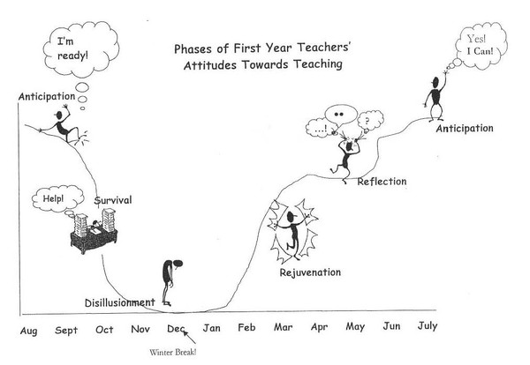**The Anticipation Phase!**



|  |
| --- |
|  |
| During the first month… -Class routines and procedures have been established.  -Classroom Expectations are posted for all students to see.  -Contacting Parents to say “Welcome.”  -Start collecting IEP’s for your students that may have them. School specific things to know… -Who is the school secretary? The custodian for your room?  -Who are my related service providers (sped, speech, OT, AT, etc.)?  -Are there any other school-specific procedures that I should know about? |

***Why include this?*** *The first year of teaching may feel like a roller coaster for many new teachers. Recognizing the phases of first year teaching can help you to reflect upon your experience and understand that you are not alone.*

The Anticipation Phase: New teachers enter with a tremendous commitment to making a difference and a somewhat idealistic view of how to accomplish their goals. One new teacher is quoted as saying, “I was elated to get the job but terrified about going from the simulated experience of student teaching to being the person completely in charge.” This feeling of excitement carries new teachers through the first few weeks of school.

**Calm the Chaos- Establishing Procedures and Expectations**

All teachers need to establish procedures and expectations to ensure that teaching time is productive. Structure and procedures are vital parts of classroom management. Every part of the day needs to be thought through and brought into alignment with what works best for your teaching style, your students’ personalities, the age group and any special challenges that could cause a distraction.

Envision each class/group/task; ask yourself what you will do and how it can be done easily. When your students arrive, get them on board by teaching each procedure, along with your content, during the first week of class. For example, explain how to enter, how get the needed supplies and start the warm-up exercise during the first few minutes of class, how to turn in and pass out work, how to work in a group, how to move between activities and how to exit the classroom. Also, be sure to cover your expectations, including how to behave in class and the consequences of misbehavior.

Procedures need to be practiced multiple times, even with older students, for all students to know and understand what’s expected. Give students feedback (positive and corrective) to ensure procedures are done correctly. This may take a couple of days or even a couple of weeks, but it will make your life easier for the rest of the school year!

**Check it out:**

**Join Pinterest at: WCSD Mentoring Program**

**and**

**Mentoring and Induction Website**



**My PGS Registration**

